TEMPO Long Range Revenue Forecast –(LRRF2022)
Nov. 16, 2021

Three forecasts
- Monthly
- Annually (Planning)
- Annually (LRRF) Due Sep 1. (hybrid)

Motor Fuel Taxes (MFT)
- Growth rates:
  - Gasoline 1.5%
  - Diesel 3.09%
  - Blends with TTI Trends after FY2024
- FY21-FY44 Increase MFT $1.8B

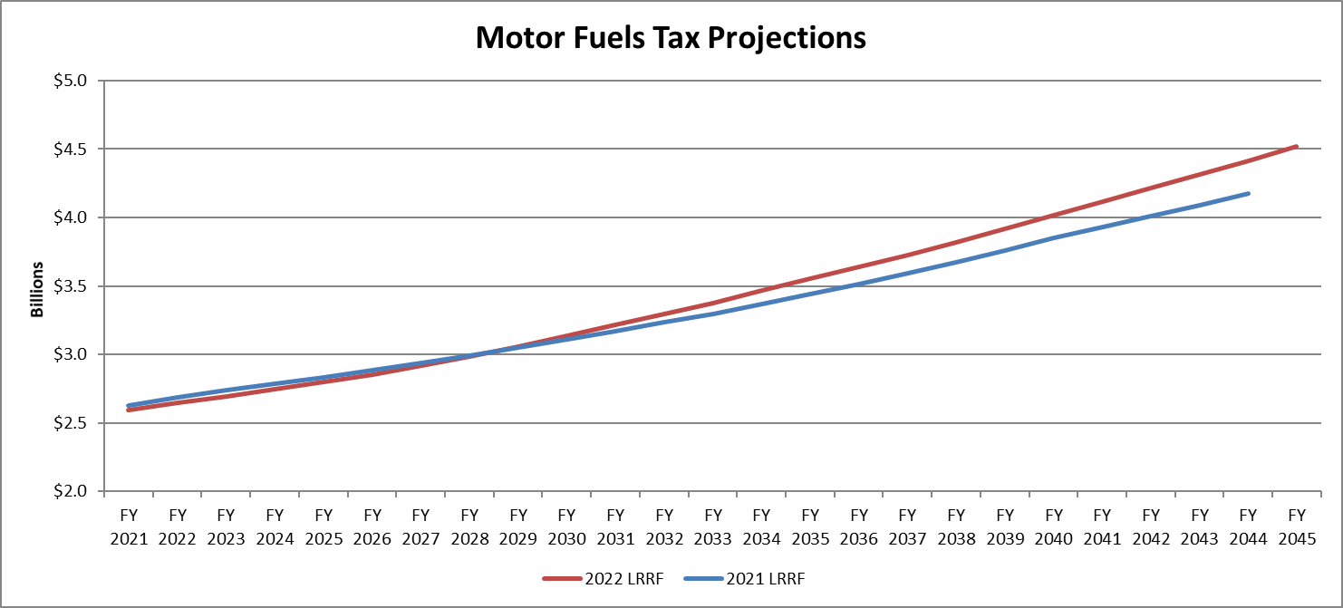

Federal
- Fast Extension thru FY2022 in the base and LRRF.
- FY21-FY44 increase in Federal OA $3.2B
- FY21 Includes $968M CRRSAA funds (COVID-19)
  - $164M for MPOs
- Does not include funding from Infrastructure Investment & Jobs Act (Nov. 2021).
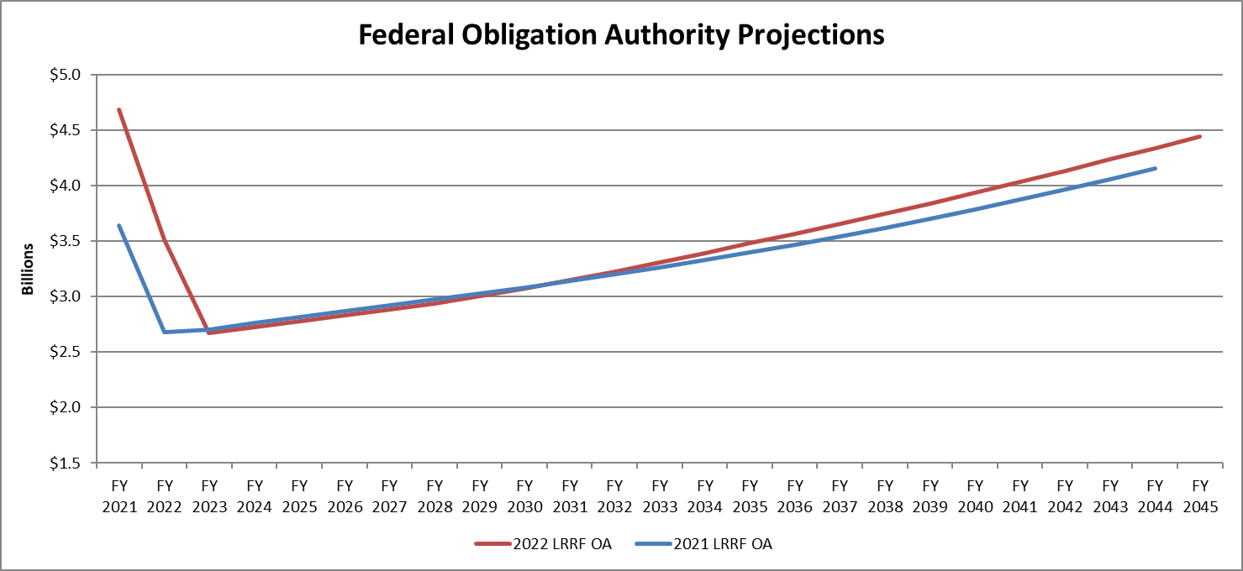

Vehicle Registration Fees
- 2.5%
- Blends with TTI Trends after FY2024
- FY21-FY44 Decrease VRF $2.3B

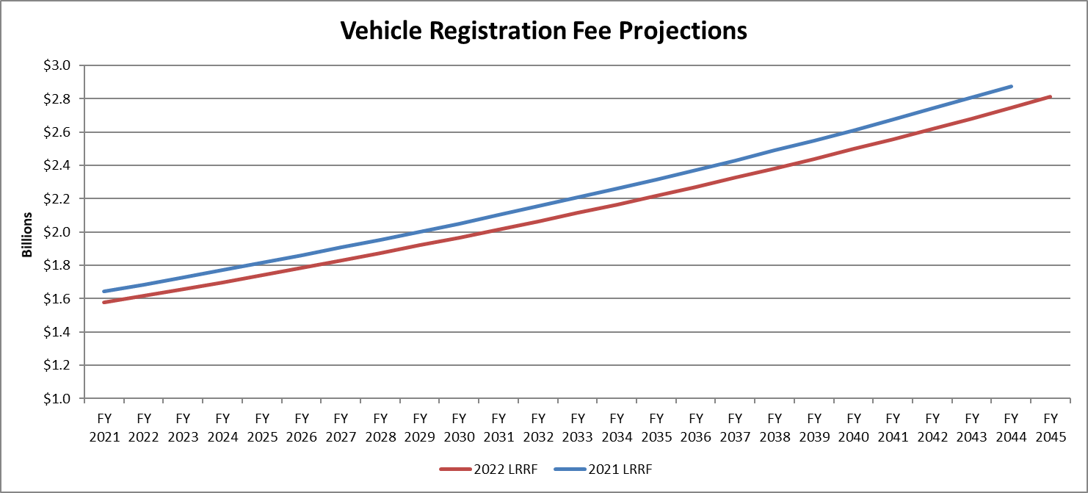

Prop 1
- FY22 - FY24 includes updates per Comptroller’s July 2021 revenue estimate revision
- FY25-FY35 Revenues of $1.306B/yr, based on new 10-year average.
- FY21-FY35 Increase $4.6B (80% letting, 20% project development)
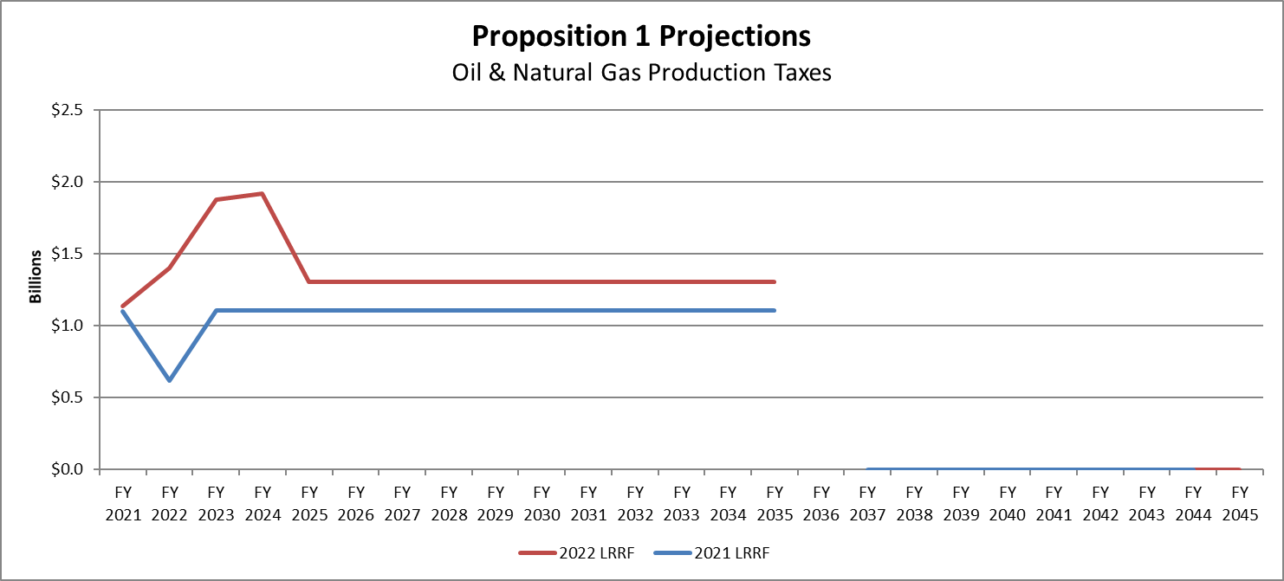

Prop 7
- Increase Motor Vehicle Sales Tax (MVST) per Comptroller’s July 2021 revenue estimate revision.
  - FY21-FY29 Increase $1.8B Revenue (80% letting, 20% project development)
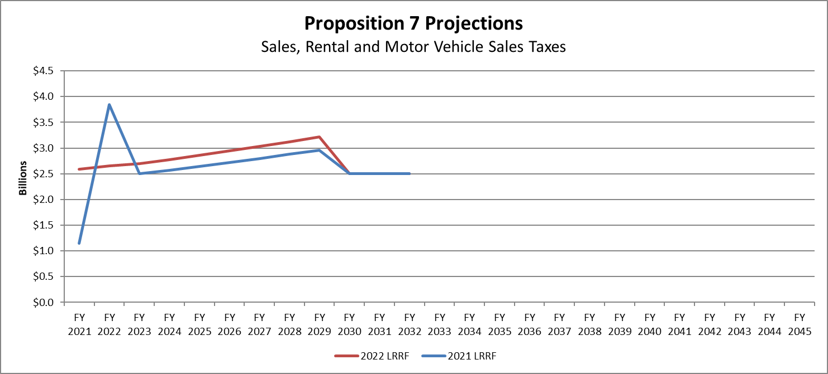

TMF Fees
- Decrease per Comptroller’s August 2021 revenue estimates.
  - FY21-FY44 Decrease $1.1B Revenue (100% project development)
    - Inspection Fees
  - FY27 decrease – SB616, 86th Leg. Driver License Fees.
  - HB 4472, 87th Leg. Redirects SHF’s TERP transfer to TMF for Certificate of Title Fees.
