STIP Dashboards Overview
Dashboard 1 – STIP Funding Categories and Amount Overview
- This dashboard shows the STIP data Funding Amounts by Category, by District or MPO, or Statewide, and by STIP Fiscal Year
- This dashboard also shows the category percentages based on the filters selected
  - The Fiscal Year and STIP Category filters adjust the graph views
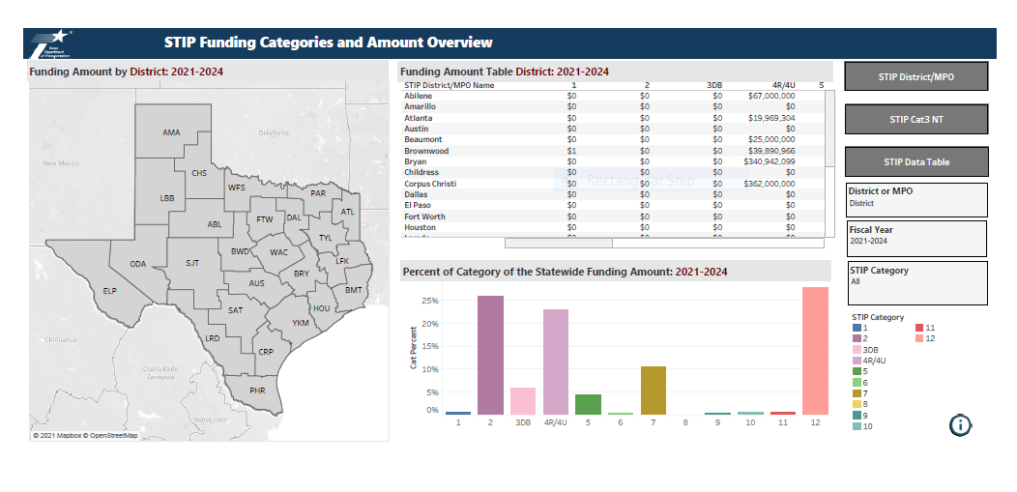
Dashboard 2 - STIP Funding Categories and Amount by STIP District/MPO
- This dashboard shows the Funding Amounts by District/MPO, by Category, and by STIP Fiscal Year
- The stacked graph displayed is the categorical Funding Amounts by District/MPO and STIP Fiscal Year filtered
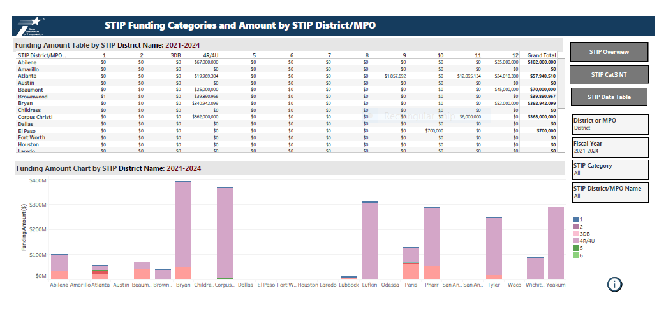

Dashboard 3 - STIP CAT 3 Non - Traditional Funding
- This dashboard shows the Funding Amounts by District/MPO, by Category, and by STIP Fiscal Year for Category 3 Non-Traditional data
- The stacked graph displayed is the type of categorical 3 funding amounts by District/MPO and STIP Fiscal Year filtered
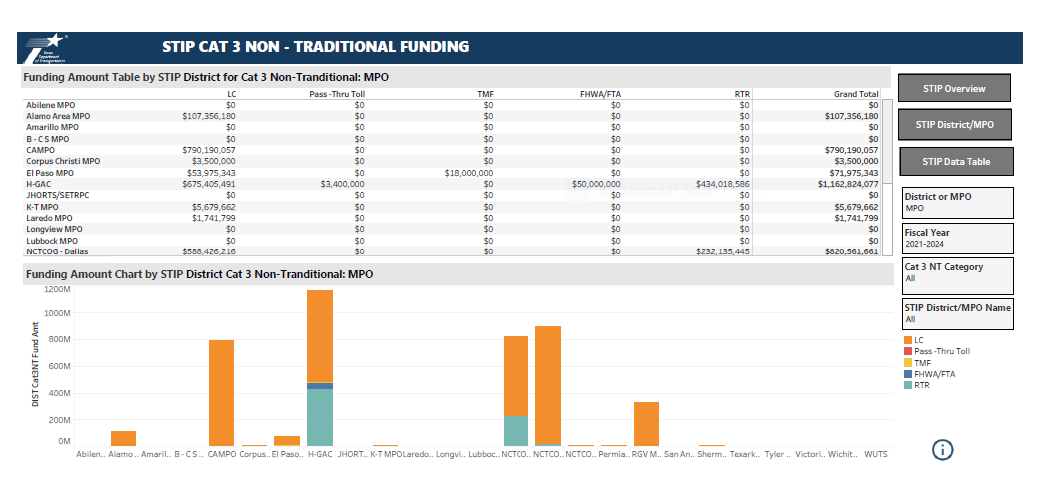
Dashboard 4 - STIP Data Table
- This dashboard shows the STIP data details for the Funding Amounts by District/MPO, by Category, and by STIP Fiscal Year
- The data can be filtered by District, STIP MPO, Category, STIP FY, or Phase [C,E,R or T]
- This dashboard version does show the phases [C,E,R,T] in the data details
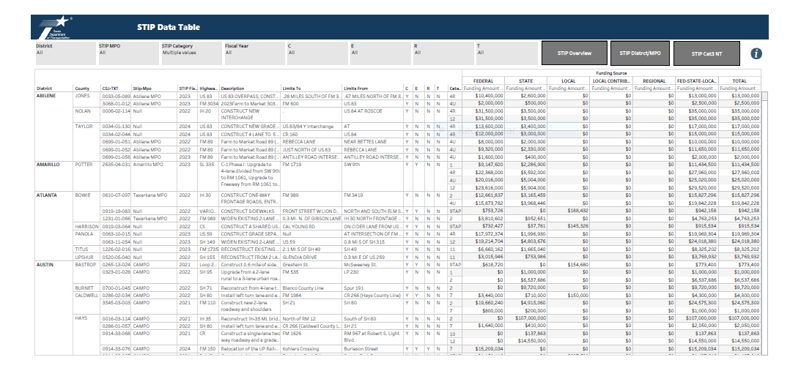

Dashboard 5 – STIP Data Table (version 2)
- This dashboard shows the STIP data details for the Funding Amounts by District/MPO, by Category, and by STIP Fiscal Year
- The data can be filtered by District, STIP MPO, Category, STIP FY, or Phase [C,E,R or T]
- This dashboard version does not show the phases [C,E,R,T] in the data details, but can be filtered to show those phases
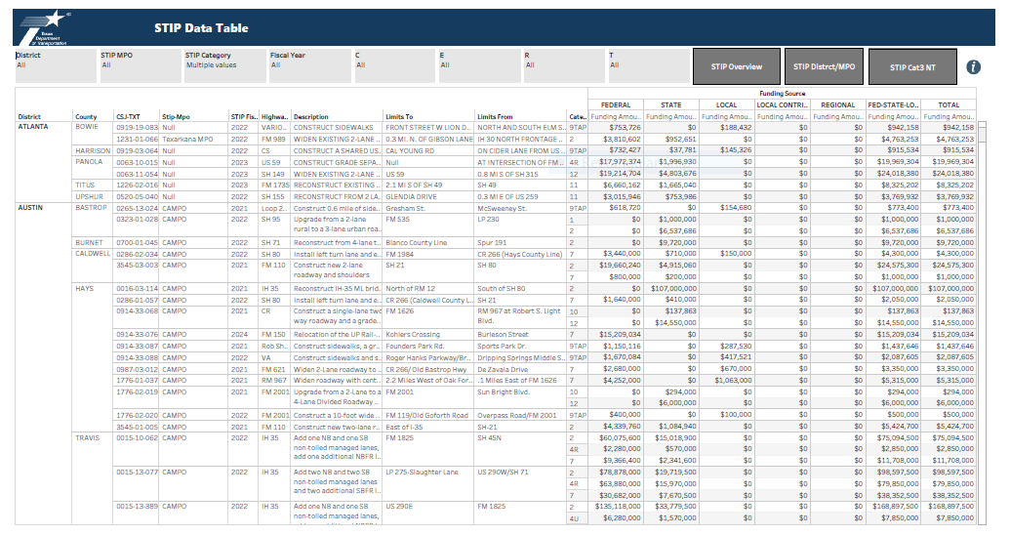
Dashboard 6 - Variance Reports: Fiscal Year Outside 4 Year Window
- This dashboard shows the Variance Report for the count of projects listed in the STIP that have TxC Fiscal Years outside the 4 Year STIP Window (> FY 2024) by District/MPO, and by TxC Fiscal Year
- There are multiple filters to select (District, STIP MPO, by Phase [C,E,R,T], STIP FY)
- Click within the count cell and the specific data details will appear below the data table
- Click ESC to unselect the cell
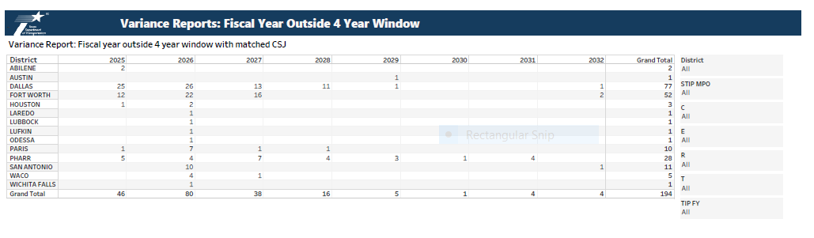

Dashbord 7 - Variance Reports: Difference Authorized Funding Amount
- This dashboard is the Variance report showing the differences between STIP Funding Amounts and TxC Authorized Amounts by Category and by District/STIP MPO, per project
- Calculation: Difference = STIP Funding Amount - TxC Authorized Amount
  - a negative amount indicates the STIP Funding Amount is less than the TxC Authorized Amount
  - a positive amount indicates the STIP Funding Amount is more than the TxC Authorized Amount
- Click within the dollar amount cell to display the data details below the data table
- Click ESC to unselect the cell
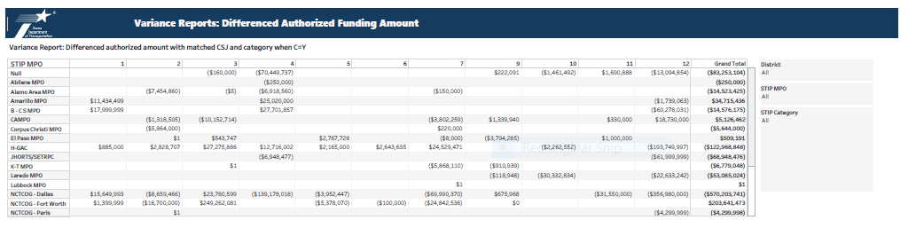
Dashboard 8 - Variance Reports: Difference Federal Funding Amount
- This dashboard is the Variance report showing the differences between STIP Federal Funding Amounts and TxC Federal Authorized Amounts by Category and by District/STIP MPO, per project
- Calculation: Difference = STIP Federal Funding Amount - TxC Federal Authorized Amount
  - a negative amount indicates the STIP Federal Funding Amount is less than the TxC Federal Authorized Amount
  - a positive amount indicates the STIP Federal Funding Amount is more than the TxC Federal Authorized Amount
- Click within the dollar amount cell to display the data details below the data table
- Click ESC to unselect the cell
