Minutes of the
State of Texas Resiliency Working Group
Summary Report on June 29th, 2021 Virtual Meeting
Contents
Attendance 1
Opening, Welcoming Comments: 2
Presentations 2
Listening Session Outcomes 2
Presentation on Senior Leadership’s Role in Embedding Transportation Resilience 4
Presentation on Mainstreaming System Resilience Concepts into Transportation Agencies: A Guide 6
General Discussion on Working Group Direction 8

Attendance

Aisa Showery
Allie Blazosky
Ana Ramirez Huerta
Andy Ralph
Annette Shepherd
Ardalan Mosavi
Barbara Maley
Bart Benthul
Ben LaBorde
Brittney Gick
Bryan McBride
Casey Wells
Catherine Wolff
Chad McKeown
Chelsea Schultz
Christie Gotti
Christopher Nelson
Craig T. Casper
Dan Kessler
Dan Rudge
Darcie Schipull
Darran Anderson
David Gierke
Deanne Simmons
Elias Rmeili
Eva Garcia
Gracie Briones
Harrison Plourde
Ibrahima Tembely
Jason Wallis
Javier Dominguez
Jayasree Korukonda
Jeffrey Howell
Jeffrey Neal
John Overman
Jolanda Prozzi
Jonathan OQuinn
Juan S. Mendive
Justin Kuzila
Justin Morgan
Kathryn Vo
Kirk Fauver
Laura Norton
Levi Stewart-Figueroa
Lily Lowder
Loretta Brown
Luis M. Diaz
Major Hofheins
Mansour Shiraz
Marisabel Ramthun
Marty Boyd
Matt Miller
Matt Sneed
Melany Rodriguez
Michael Flood
Michael Meyer
Mohammad Al Hweil
Nicholas Cousineau
Pat Bye
Paula Sales-Evans
Pete Madrid
Phillip Tindall
ReaDonna Jones
Robert MacDonald
Robert Ramirez
Roberto Rodriguez III
Roberto Rodriguez III
Ryan Granger
Sara Garza
Shirley Li
Sonia Perez
Stephen Keen
Todd Carlson
Travis Muno
Uryan Nelson
Yoshiko Boulan
Zeke Reyna

Opening, Welcoming Comments:
Jeff Neal made brief introductory remarks in reviewing the agenda. Jeff advised that this meeting will cover outcomes of the listening sessions to meet with smaller groups of MPOs to ensure we will discover best ways for the resiliency working group to be a resource for MPOs. One of the larger topics is to cover information appropriate to the web portal and associated technical resources and tools connected to the portal. Jeff also introduced how presentations will cover more focused topics on how to communicate resilience to decision makers and stakeholders as well as integrate resilience into MPO long range planning and project selection processes.

Jeff indicated that a challenge to the group in advancing the state of practice for resilience in MPOs is building an effective linkage between resilience and planning, project development, asset management, and sustainability efforts so as to avoid it being siloed within each as disparate, low-coordination elements.

Presentations

Listening Session Outcomes
Matthew Miller, Texas A&M Transportation Institute

Matthew Miller made the following key observations:
- Described outcomes of discussions on the top five strategic needs for each region based on Texas MPO responses to the February 2021 resilience survey.
  - In the coastal region MPOs identified coastal routes and man-made impacts of port facility disruptions and hazardous chemicals associated.
  - In the northeast region alternate routing and tools to analyze regional risk tied to extreme weather, bridge strikes, and major crashes.
  - In west Texas, the listening session focused on man-made side of regional disruptions focused on strategies at the magnitude of incident clearance, TSMO improvements, and response planning for vulnerable, critical corridors, inclusive of cross-border items as well (general labor strikes, bomb threats, etc.).
  - Central Texas MPOs went through an ordering exercise and from the discussion the group reordered their top five needs by identifying critical infrastructure, estimating regional response, and identifying alternative corridors, as first three to achieve, followed by development of an adaptable framework and application of analytical strategies.
- Matt presented additional results from the survey showing how rankings shifted on the top ten resiliency needs based on 4 recently completed surveys (since the February results).
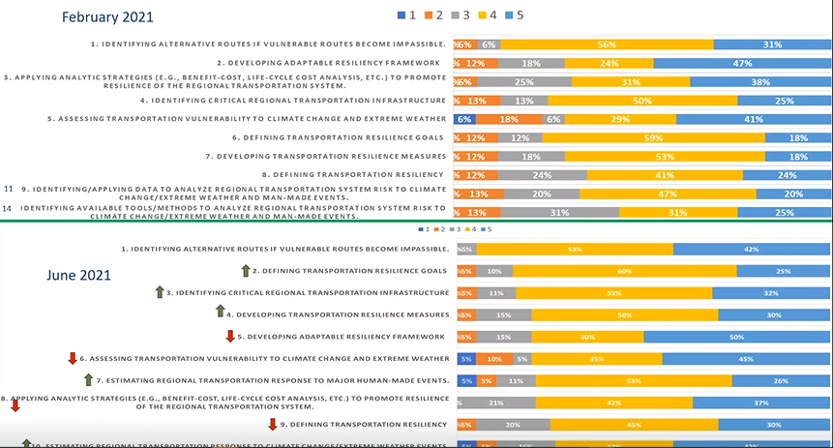

- Matt interpreted these shifts to mean that Texas MPOs are:
  - Moving to a consensus on strategic needs for first things first- and that is that the definition of resilience goals, critical measures, and identification of critical infrastructure are moving up and staying in the top 5.
  - Alternative routes remains at the top because it is pragmatic and actionable in nature, getting the traveling public around disruptions in restoring operations to as close to normal as possible while ensuring safety.
- Matt advised that in all sessions, emergency response, and operational response really remained at the top of mind from participants whether for resources, tools, or data needs.
- Matt advised that in the five-step framework:
  - A corridors approach and project development approaches was requested to be explicitly referenced in the framework.
  - There is uncertainty on the 25-year history and concern about whether it can actually be developed going back that far.
  - Regional emergency response plans in place as result of DHS funding will likely form the foundation of their information on disruptions history, hazards impacts, and critical infrastructure identification.
- Matt advised that the resilience resource portal discussion highlighted many needs, from training on how to communicate resilience to policy boards and technical activities committees, to tools and guidance on project selection process updates based on resilience metrics, and how to evaluate alternative investments and designs that mitigate extreme weather and man-made disruptions.
  - Operational functions and data visualizations was also referenced comparing TSMO and traveler information systems like ATX Floods and Transtar and thinking through how to apply in or deploy in a resource portal.
- Matt showed word cloud responses for each region on the type of resilience data, tools, and resources to be included, and that flood, infrastructure age, and incident data were repeated requests from MPOs across most regions.
- Matt showed open-ended question responses on how MPO will use the resource portal, and most responses focused on project scoring and selection updates.
- Matt showed an example of a completed resource web portal in the Texas Pedestrian Safety Resource Library (https://www.txpedsafetyresources.org/) and displayed the complete list of 28 resource portal needs gained during the discussion. He advised that these needs will be sorted and organized for priority in next steps discussion with leadership.
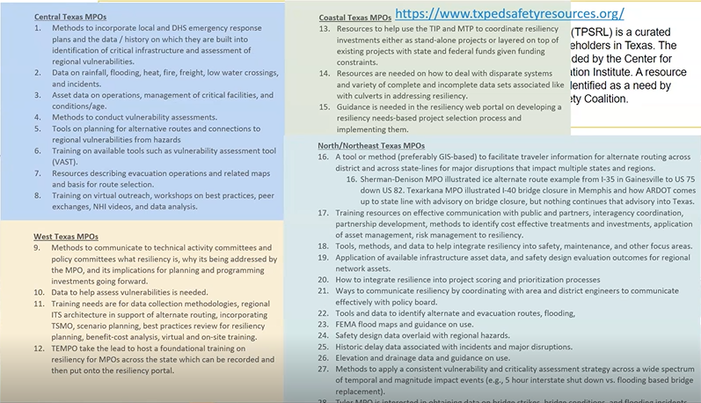

Presentation on Senior Leadership’s Role in Embedding Transportation Resilience
Pat Bye, WSP
Today talking about leaderships role in resilience. The project was to develop a primer for resilience for ceos. Interviewed dot ceo’s 1 on 1; and thru summits and regional meetings. Participatd in peer exchanges, forums, and webinars and conducted other research. By now we all have understanding of resilince from. Definitions – plan for events. As reported by noaa during 2020- 22 separate billion dollar
Pat Bye made the following key observations:
- They developed a primer to communicate resilience to state DOT CEOs.
- CEO’s indicated state DOTs are “largely good at recovery, but figuring out how to prevent it is the challenge”. This indicates that preparing a regional network to effectively mitigate against man-made and extreme weather events is still a primary challenge, not the operational response to it.
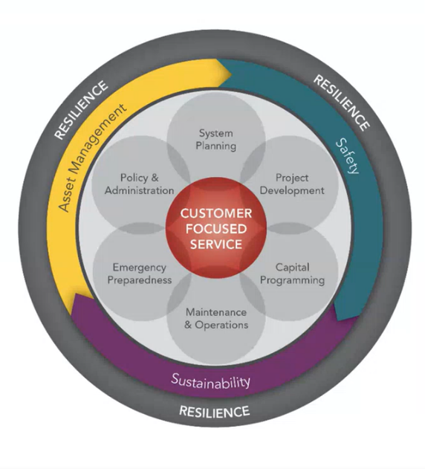
- Senior managers indicated resilience is most effective if it is part of everyone’s job and mindset, and if there is cross-functional collaboration and coordinated decision making.
- Operations and maintenance know where regular vulnerabilities are and maintenance needs (e.g., clearing culverts before a storm, etc.) and serve as critical members to design team inserting operations and maintenance in early project development stage.
  - Oregon DOT uses data from maintenance to identify and map vulnerable areas and track over time to get idea of what is gong on.
  - Alabama operations uses trucks that double as snow plows when needed.
- Emergency operations and response recovery plans should be considered within project selection, investment, planning, and design, and in turn should be updated with operations and maintenance data referenced on item 4a above.
- States included vulnerability, such as hurricane vulnerability along the coasts of Florida into design. For example, in Florida, signs and signals are designed with mast arms on coastal areas to be more resilient to withstand hurricane wind loads.
  - Maine increased design standards for culverts and bridge replacements after hurricane sandy.
- Make sure to identify cost savings and co-benefits associated with decreased operating or maintenance costs or improvements in adjacent safety performance measures.
- The full scope of resilience is where leadership is best positioned to address this cross- department collaboration.
  - Leaders need to know resilience improves safety, saves, money, know its relation to mission of state DOTs.
  - Resilience (ability to adapt, respond, and recover), safety, and customer service are the new core “three legged stool” for how state DOTs function going forward.
  - Leaders use risk management, and outputs of scenario planning exercises to balance long and short term needs of the state DOT and to make decisions that address long term risk averse resilient system.
- Leaders champion resilience by having a clear story on what it means and using that story to convince legislature, the business community, and the governor to support resilience efforts even when impacts are not immediate and efforts can be costly.
  - Set the tone within the state DOT by supporting staff time spent on resilience and welcoming innovative, adaptive thinking and actions, and give resilience projects high profile when achieved (e.g., ribbon cutting ceremonies, etc.).
- The importance of resilience is communicated simply by:
  - stating what the transportation system is, how it functions and what is done to maintain it;
  - describe work being done to reduce disruptions and improve safety, and
  - capping this off with how the notion of resilience informs all of this.
- Resilience performance measures are developed for strategy, capital investment, and operations to track current level of system resilience, and document benefits of investments planned.
- Standardized resilience measurements do not yet exist, so it is imperative to use the existing performance measures and performance data for mobility, safety, security, and economic efficiency, because they all relate to resilience.
- Learn: conduct post-disruption reviews and incorporate lessons learned into wider protocols as well as update hazards vulnerability/critical infrastructure assessments.

Presentation on Mainstreaming System Resilience Concepts into Transportation Agencies: A Guide
Michael Flood and Michael Meyer, WSP
Michael Flood and Professor Michael Meyer made the following key observations:
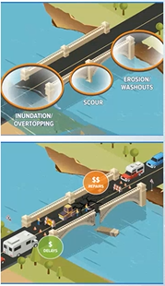
- Risk and risk management factor heavily in organizational change management perspectives for state DOTs addressing resilience as a cross-departmental function that prioritizes the minimization of impacts of transportation system disruption.
- WSP is developing research that slots resilience into a capability maturity model (CMM) framework to enable state DOTs and MPOs to use a self-assessment approach to determine how advanced they are in terms of resilience planning.
- MassDOT applies a 5-step planning-level risk assessment, moving from general cause and condition effects to a drill down into delays and repair costs based on available data sources (e.g., coastal flooding program). The approach looks like this:
  - 1) If precipitation occurs where do floods happen; and 2) if floods happen what assets are at risk; and 3) if asset is at risk what happens there; and 4) if damaged how much will it cost to repair and how long will it be out of service and what are total delay costs added to repair costs for priority purposes.
- Self-assessment is based on a CMM that uses ten steps (below) that are scored on a three point scale to evaluate how well the state DOT or MPO addresses resilience
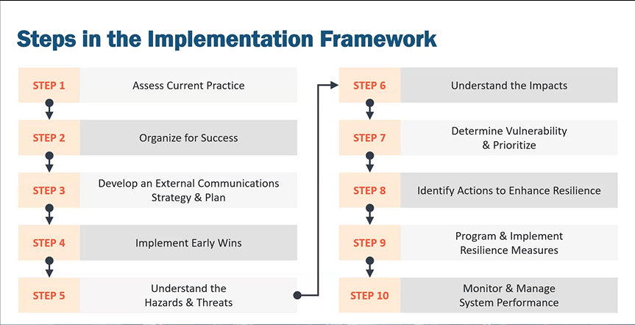

- Each step has a chapter in the guidebook with multiple sub-step factors in the self-assessment based on case studies and research. Based on outputs of the self-assessment, agencies will be able to determine where they need to improve as per the visual example below.
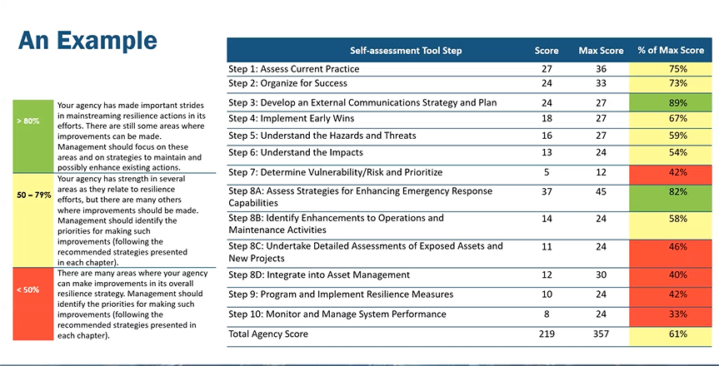
- The report also splits up the sub-steps and steps into functional areas of planning, project development and engineering, and emergency response, so this enables agencies to focus on functional areas pertinent to them. It was recommended that MPOs may focus on the 24 planning factors.

General Discussion on Working Group Direction
A) Web Portal Design, Development, Funding, and Potential Timelines

- Matthew Miller inquired about resources to add to the portal containing elements of self-assessments or ratings of resources and methods within in terms of organizational lift required to apply them.
  - Mike Meyer advised that by the end of 2021 calendar year, there will be a downloadable self-assessment tool based on the guidebook with a spreadsheet-type mechanism enabling agencies to select factors applicable to their use in rating the strength of their resiliency program.
  - Mike Meyer advised that the NCHRP research does not contain details on anticipated staff needs or budgeting to effectively address each sub-step or planning factor, but that some states have set aside program funds dedicated to upgrade system to minimize disruption.
  - Mike Meyer advised that it is anticipated that new infrastructure funds will be available to cover costs of increased resilience.
  - Mike Meyer advised that it is the forward-looking planning work that is on the central plate of MPOs mission which really set the tone and focus for ensuring resiliency on regional transportation networks. Decision makers who select funds for region and projects, should be informed of the consequences of underinvesting in assets that are in the strike zone for these major man-made and extreme weather events and the risk their being down carry for the regional network.
- Kirk Fauver suggested we cover foundational training and communication training/outreach to decision makers in the web portal.
  - Caltrans requested training on the back end of a WSP study and now WSP is involved in designing an NHI course that involves training for project developers and planners in the topic of resilience.
- Jeffrey Neal advised that a mission item or description that occurred to him that is central to the TEMPO resiliency working group is to serve as an extension for MPOs with less staff to help coordinate with TxDOT, and simplify evaluations by rendering foundational resilience data for critical infrastructure assessments and vulnerability assessments useful to the decision making and project selection process.
- Jeff Neal and Major Hofheins advised that they agree with Kirk on training as a central need or output of the resiliency working group. Jeff further advised that training on the full spectrum of resilience needs from major disruptions to changes in rail frequency all would potentially fit within this resilience training need.

