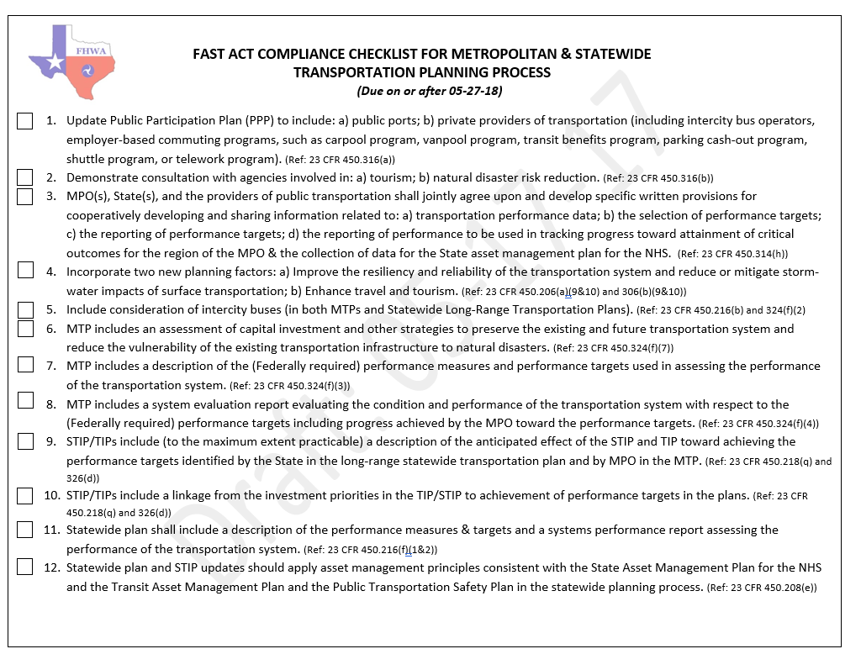
Enclosure No. 1- FAST Act Checklist for Metropolitan & Statewide Planning Process (for TIP/MTP Revisions and Conformity Determinations on or after 05-27-18)

MEMORANDUM OF UNDERSTANDING
Enclosure No. 2- Memorandum of Understanding Among MPO(s), TxDOT, and Public Transportation Operators (for TIP/MTP Revisions and Conformity Determinations on or after 05-27-18)
AMONG
THE ______________METROPOLITAN PLANNING ORGANIZATION (“MPO”),
THE TEXAS DEPARTMENT OF TRANSPORTATION (“TxDOT”) AND
THE ___________________________ PUBLIC TRANSPORTATION OPERATOR

WHEREAS, the Fixing America's Surface Transportation Act (FAST Act) promulgated regulations 23 CFR 450.314, and
WHEREAS, the MPO, the State and the Public Transportation Operator(s) are required by 23 CFR 450.314 to cooperatively determine their mutual responsibilities in carrying out the metropolitan transportation planning process, and
WHEREAS, these responsibilities shall be clearly identified in written agreements among the MPO, the State and the Public Transportation Operator(s) serving the Metropolitan Planning Area (MPA), and
WHEREAS, to the extent possible, a single agreement between all responsible parties should be developed, and
WHEREAS, the federal regulations require the written agreement to include specific provisions for cooperatively developing and sharing information related to the development of financial plans that support the metropolitan transportation plan (MTP), the metropolitan Transportation Improvement Program (“TIP”), and development of the annual listing of obligated projects.
[If, in nonattainment or maintenance areas, the MPO is not the designated agency for air quality planning under section 174 of the Clean Air Act (42 U.S.C. 7504), insert the following whereas statement]
WHEREAS, the MPO and the designated air quality planning agency entered into a written agreement on _______ [insert effective date of agreement] describing their respective roles and responsibilities for air quality related transportation planning.
[If more than one MPO has been designated to serve an MPA, insert the following whereas]
WHEREAS, TxDOT, the MPOs [name MPOs], and the public transportation operator(s) entered into a written agreement on _______ [insert effective date of agreement] describing how the MPOs shall coordinate data collection, analysis, and planning assumptions across the MPA to ensure the development of consistent MTPs and TIPs with respect to that transportation improvement.
[If more than one MPO serves an MPA, where the MPA includes a UZA that has been designated a TMA in addition to an UZA that is not designated a TMA, include the following whereas]
WHEREAS, [Name of MPO] MPO, designated as a Transportation Management Area (TMA), entered into a written agreement on [insert effective date of agreement] with the [Name of MPO] with which it overlaps the MPA boundaries, describing the roles and responsibilities of each MPO in meeting specific TMA requirements
WHEREAS, the federal regulations require that the MPO, State DOT, and the public transit provider shall jointly agree upon and develop specific written procedures for cooperatively developing and sharing information related to transportation performance data, the selection of performance targets, the reporting of performance targets, the reporting of performance to be used in tracking progress toward attainment of critical outcomes for the region of the MPO, and the collection of data for the State asset management plan for the National Highway System (NHS).
NOW THEREFORE, the parties agree as follows:
- Purpose. It is the purpose of this Memorandum of Understanding (MOU) to make provision for cooperative mutual responsibilities in carrying out the Metropolitan Planning Process and Performance Based Planning and Programming in the _________ MPA and to provide a single agreement between the State of Texas acting through the Texas Department of Transportation (TxDOT), ___________ MPO, and ___________[list Public Transportation Operator(s)] in accordance with current Federal Legislation and as required by 23 CFR 450.314.

- Responsibilities of all parties.
All parties will:
- Cooperatively determine their mutual responsibilities in carrying out the metropolitan transportation planning process in a performance based planning format and final form. Decide upon and adopt performance targets for this planning process in accordance with Federal and State requirements and guidance.
- Make provisions for cooperatively developing and sharing information related to the development of financial plans that support the Metropolitan Transportation Plan (“MTP”) and TIP.

- Ensure TxDOT, the Public Transportation Operator(s) and the MPO cooperatively develop a listing of projects that comprehensively address the transportation system within the MPO boundaries. Identified projects shall include both roadway and transit initiatives, including but not limited to investments in pedestrian walkways and bicycle transportation facilities for which federal funds were obligated in the preceding fiscal year.

- Ensure that the UPWP will detail and document these responsibilities, deliverables and associated costs.

- Performance Based Planning & Programming

- Developing transportation performance data

  - TxDOT will provide the MPO with a subset for their MPA of the state performance data used in developing statewide targets.

  - If an MPO chooses to develop their own target for any measure, they will provide TxDOT with any supplemental data they utilize in association with the target-setting process.

- Selection of transportation performance targets

  - TxDOT will develop draft statewide federal performance targets in coordination with the applicable MPOs. Coordination may include in-person meetings, web meetings, conference calls, and/or email communication. MPOs shall be given an opportunity to provide comments on statewide targets one month prior to final statewide targets adoption.

  - If the MPO chooses to adopt their own target for any measure, it will develop draft MPO performance targets in coordination with TxDOT. Coordination methods will be at the discretion of the MPO, but TxDOT shall be provided an opportunity to provide comments on draft MPO performance targets prior to final approval.

- Reporting of performance targets

  - TxDOT performance targets will be reported to FHWA and FTA, as applicable. The MPO will be notified when TxDOT has reported final statewide targets.

  - MPO performance targets will be reported to TxDOT.

    - For each target, the MPO will provide the following information no later than 180 days after the date TxDOT or the Public Transportation Operator establishes performance targets, or the date specified by federal code:

      - Written agreement to plan and program projects so that they contribute toward the accomplishment of TxDOT or Public Transportation Operator performance target, or;

      - Written notification that the MPO will set a quantifiable target for that performance measure for the MPO’s planning area.

        - If a quantifiable target is set for the MPO planning area, the MPO will provide any supplemental data used in determining any such target.

      - Documentation of the MPO’s target or support of the statewide or relevant public transportation provider target will be provided in the form of a resolution or meeting minutes.

  - TxDOT will include information outlined in 23 CFR 450.216 (f) in any statewide transportation plan amended or adopted after May 27, 2018, and information outlined in 23 CFR 450.218 (q) in any statewide transportation improvement program amended or adopted after May 27, 2018.

  - The MPO will include information outlined in 23 CFR 450.324 (g) (3-4) in any MTP amended or adopted after May 27, 2018, and information outlined in 23 CFR 450.326 (d) in any TIP amended or adopted after May 27, 2018.
  - Reporting of targets and performance by TxDOT and the MPO shall conform to 23 CFR 490, 49 CFR 625, and 49 CFR 673

- Reporting of performance to be used in tracking progress toward attainment of critical outcomes for the region of the MPO

  - TxDOT will provide the MPO with an update of the subset for their MPA of the state performance data used in developing statewide targets including prior performance data.

- The collection of data for the State asset management plans for the NHS

  - TxDOT will be responsible for collecting bridge and pavement condition data for the State asset management plan for the NHS.

- Responsibilities of the MPO

The MPO will:

- Work in consultation with Public Transportation Operator(s) and TxDOT in developing the financial plan for the MTP.

- Work in consultation with Public Transportation Operator(s)and TxDOT in developing the financial plan for the TIP.

- Conduct Technical Committee and Policy Board meetings as required and necessary.

- In consultation with Public Transportation Operator(s)and TxDOT, update the MTP and TIP in accordance with State and Federal laws.

- Invite Transit Districts to participate in all public participation processes.

- Conduct comprehensive, cooperative and continuous transportation planning for the _________________ MPA.

- Establish necessary transportation performance targets, share information related to the performance data, and document the reporting of performance to be used in tracking progress toward attainment of critical outcomes within the MPO MPA, if the MPO elects to develop quantifiable targets for performance measures for the MPO’s planning area.

- Responsibilities of the Public Transportation Operator(s)

The Public Transportation Operator(s) will:

- Work in consultation with the MPO in developing short-range and long-range plans for transit for inclusion in the MTP.

- Assist in validation of data used as input into the transportation plan.

- Work in consultation with the MPO and TxDOT in developing the financial plan for the MTP.

- Work in consultation with the MPO and TXDOT in developing the financial plan for the TIP.

- Provide the MPO with the annual list of transit obligated projects.

- Serve on the MPO Technical Committee and Policy Board as applicable.

- Notify the MPO of changes to projects that would affect the MTP or TIP.

- Invite the MPO to participate in all public participation processes.

- Establish transit asset management performance targets and share with the MPO and other interested parties.

- Responsibilities of TxDOT.

- Work in consultation with Public Transportation Operator(s) and the MPO in developing the financial plan for the TIP and MTP.

- Assist in the validation of data used as input into the transportation plan.

- Provide the MPO with the annual list of obligated projects.

- Serve on the MPO Technical Committee and Policy Board.

- Notify the MPO of changes to projects that would affect the MTP or TIP.

- In consultation with the MPO and Transit District, update the MTP and TIP in accordance with State and Federal laws.

- Work in consultation with the MPO and Public Transportation Operator(s) in developing short-range and long-range plans for transit for inclusion in the MTP and TIP.

- Term. This Memorandum shall become effective as to each Party when fully executed by all parties. It shall remain in full force and effect until such time it is terminated in writing by one or all of the parties.

- Validity and Enforceability. If any current or future legal limitations affect the validity or enforceability of a provision of this MOU, then the legal limitations are made a part of this MOU and shall operate to amend this MOU to the minimum extent necessary to bring this MOU into conformity with the requirements of the limitations, and so modified, this MOU shall continue in full force and effect.

- Governing Law and Venue. This MOU shall be governed by the laws of the State of Texas. Venue for an action arising under this MOU shall lie exclusively in Travis County, Texas.

- Severability. If a provision contained in this MOU is held invalid for any reason, the invalidity does not affect other provisions of the MOU and can be given effect without the invalid provision, and to this end the provisions of this MOU are severable.
(SIGNATURE PAGE TO FOLLOW)

EXECUTED by the parties hereto, each respective entity acting by and through its duly authorized official as required by law.

_________________________ Date: ________________
Chairperson of the MPO Policy Board

_________________________ Date: ________________
Public Transportation Operator
General Manager

_________________________ Date: ________________
Texas Department of Transportation
District Engineer

Approved as to Content:

_________________________

Director
Metropolitan Planning Organization

Appendices:

- Safety Performance Measures
- Highway Safety Improvement Program
- FHWA Pavement and Bridge Performance Measures
- FHWA System Performance Measures
  - NHS
  - Freight
  - CMAQ
- FTA Transit Asset Management
- FTA Agency Safety Plan

[Recommend inclusion of a summary describing the anticipated purpose, content and structure of the appendices.]

